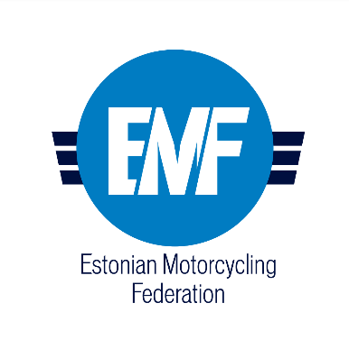

Lost in Woods E-Bike Cup Holstre 2023

I. Time, location, competition classes
Time: October 7, 2023
Location: Holstre-Polli Spordikeskus, Viisuküla, 69607
google maps: https://maps.app.goo.gl/LyjABLxeKyGy79Nq6
google maps: Holstre-Polli Spordikeskus
Event classification: E-Bike Cup IV etapp

E-bike classes:
- E-Men
- E-Junior (12-16)
- E-Women
- E-Open (derestricted/tuned bikes)

Bike classes:
- Men
- Women
- Junior (12-16)

II. Event organizers and contacts
Organizer: EMTB ESTONIA OÜ +372 5398 3108 info@vingevant.ee
Track design: Ranno Kivistik +372 5398 3108 ranno.kivistik@gmail.com
Timing: Antrotsenter OÜ
Ambulance: Tartu Kiirabi SA
Catering: Holstre-Polli Spordikeskus
Announcer: TBA
Photo/video: TBA

III. Schedule
Registration, technical control: 10:00-11:30
Track walk: 10:00-11:30
Competitors meeting: 11:30
First start (lap 1): 12:00
Second start (lap 2): 13:00
Third start (lap 3): 14:00
Awards: 15:00-15:30

The starting order is determined in the order of the competition classes. It will be specified on the spot.

IV. Pre-registration and participation fees

Pre-registration:
Until 6.10.2023 on website www.msport.ee

Participation fee:
Each competitor must pay a participation fee of 35€ when registering for the competition.

Prepayment:
Recipient: EMTB ESTONIA OÜ
Account no: EE857700771005214324
Description: competitor name and class.

Payment on the spot in cash!

The participation fee includes catering and sauna/washing facilities after the competition.
V. Competition rules
Competition rules according to Estonian E-bike enduro championship and cup rules.

VI. Track
Race track: the length of one lap is approx. 8 km, with 3 different stages (~2 km). The crossing (~0,6km) between stages is not limited in time, but overall lap time is limited to 1 hour. Control time for the entire competition, will be determined on the spot (depends on the number of competitors).

All competition classes will ride 3 laps.

VII. Awards
The top three in each class will be awarded after the last competitor finishes within 30 minutes.

