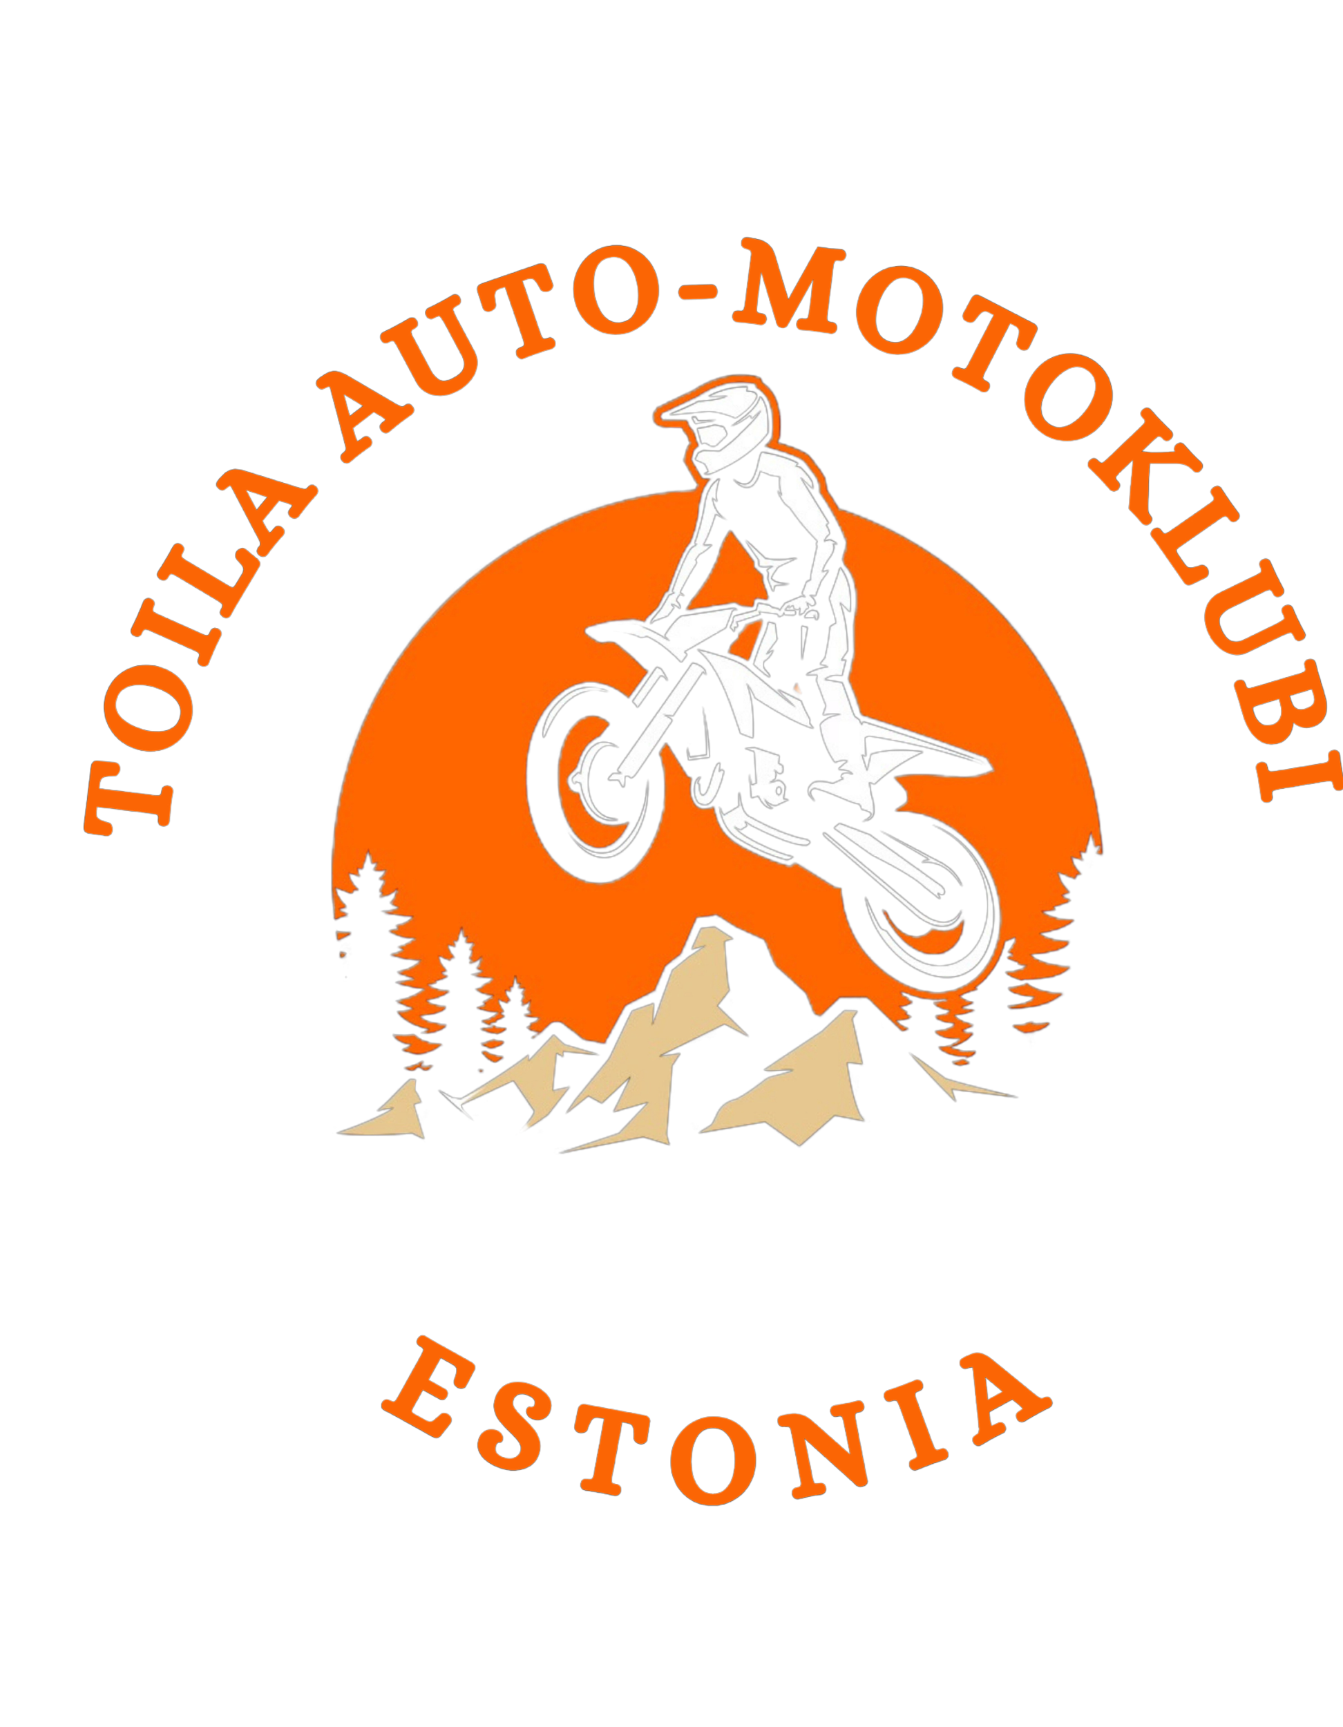

KOHTLA-NÕMME ENDURO 2026
Enduro Estonian Championship Round 2

DATE AND LOCATION:
August 15, 2026, Kohtla-Nõmme, Jõhvi Municipality, Ida-Viru County
https://maps.app.goo.gl/KnAjhKfNnhvsAHXL9

ORGANIZER:
MTÜ TAMK (Toila Auto-Motoklubi) tamk.mtu@gmail.com Tel.+372 5595 6626
MTÜ Kohtla-Nõmme Motoklubi

MOTORCYCLE CLASSES:
EMV: E 1 , E 2 , E 3, E 40+, E Juunior 16, EGP
EKV: Hobby, Algajad, Veteran 50+, Veteran 60+, Uustulnuk, Naised

COMPETITION MANAGEMENT:
Responsible for organization:
Responsible person: Tanel Kingu tel +37256258629 EMF 737
Chief Judge: Toomas Merilai tel +37255956626 EMF 655
Peasekretär: Martti Troon tel +3725288121 EMF 728
Secretariat: Toomas Merilai tel +37255956626 EMF 655
Rajameister: Rauno Voldek tel +37256258629
Tehniline kontroll: Kalju Murunit tel +37255547686 EMF 734
Peaajamõõtja: ANTROTSENTER OÜ tel +3725518729
Meditsiin: Kaarel Lehtoja tel +37256273074

RACE CENTER/SECRETARIAT
KOHTLA-NÕMME PRIMARY SCHOOL
Kooli 6 Kohtla-Nõmme, Ida-Viru County

SCHEDULE
August 15, 2026
Registration 8:00–10:45
Technical Inspection 8:00–11:00
Riders' Briefing 11:30
START 12:00

REGISTRATION
Kohtla-Nõmme enduro EMV/EKV 2026 - Eesti Mootorrattaspordi Föderatsioon
Pre-registration ends on Thursday, August 13 at 18:00
Entry fee: €70
Late registration adds €10 to the entry fee.
Each registered participant must have valid competition insurance (e.g. with a license issued by a national motor federation). One-time insurance can be purchased on-site for the event.

STARTING ORDER
The starting order will be determined according to competition rules.

TRACK
Track length is 43,75 km with one Enduro Test (ET), one Cross Test (CT), one Extreme Test (XT) and 2 time checkpoints.

Number of laps by class:
EMV and Hobby classes: 3 laps
EKV classes: 2 laps
Veteran 60+: 1 lap
The final lap Enduro Test is a POINT SCORING TEST

Use of a mat is mandatory during refueling.
Each club must have a 6 kg powder fire extinguisher in the refueling zone.

AWARD CEREMONY
The top three in each class and in the overall ranking will be awarded trophies.

SEE YOU IN KOHTLA-NÕMME!

